Do you suck your thumb? We used to suck our thumbs, too. A lot of babies and toddlers suck their thumbs. But, sucking your thumb can be harmful to your ‘big kid’ teeth.
Let’s talk about some ways to help you stop.
Do you suck your thumb at night? Sometimes asking an adult to help you by putting gloves or socks on your hands before you go to bed can help.
A bandage on your thumb during the day can help remind you not to suck your thumb. Ask your Mom or Dad to use one that has bright colors on it to make it more fun. The bandage will feel funny in your mouth and it won’t be much fun to suck your thumb.
It can be embarrassing to suck your thumb at school or when you are invited to stay over at a friends’ house. Lots of kids still suck their thumbs by the time they are in school, but it is a good thing to stop. Your ‘big kid’ teeth will love you for it.
Here’s a chart our parents used to help us stop sucking our thumbs.
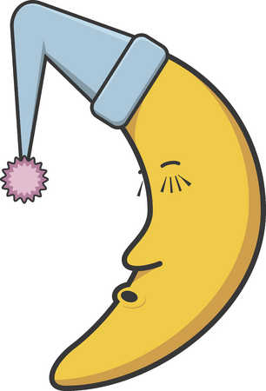
Monday
Tuesday
Wednesday
Thursday
Friday
Saturday
Sunday

