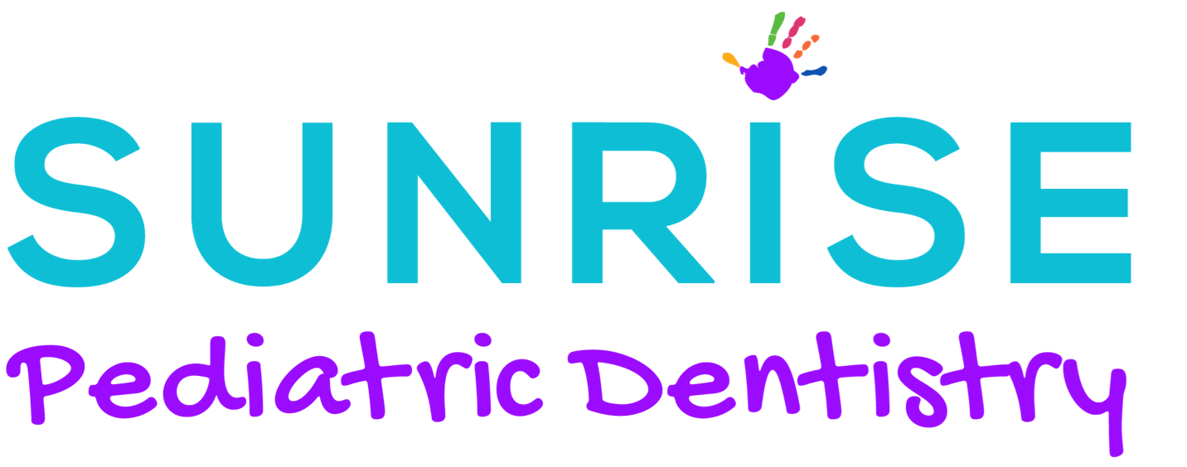

Post-op Exercises – Toddler/Child

Avoid chewing until numbness has worn off if anesthetic was used. Avoid hard foods for the first 24 hours following treatment. Avoid straws and fizzy drinks for the first 24 hours. Some sensitivity to hot cold and pressure is normal. You may be sore for several days. Over the counter pain medication is recommended following all labels and directions. Rinse mouth with warm salt water and if you have persistent pain, contact the office/dentist right away.

Exercises are not optional! The first 24-48 hours of stretches are critical to prevent reattachment of the tissue and should be performed every 3-4 hours (can occur prior to feeds) and continued for 2 weeks total.

Positioning: Position your baby in the same manner as the procedure was performed (knee to knee most typical or on changing table). Please wash your hands before performing the stretches.

*Lingual- Each exercise in repetitions of 3, 5x a day for 6 weeks

- Lift tongue with two fingers fully until the diamond is fully visible, hold for a count of three, then release.

- Lightly massage around diamond border or sweep finger through underneath.

- Have baby suck on index finger (pointed towards roof of mouth) and pull back, allowing child to suck finger back in.

- After 1 week massage under the tongue, over the incision daily for 6 weeks as the body lays down collagen for that long.

*Labial- Each exercise in repetitions of 3, 5x a day for 6 weeks

- Lift lip with two fingers fully until the diamond is fully visible then release.

- Sweep finger under lip to check for re-attachment will feel a bump, string, or finger will get caught.

STRETCHES SHOULD BE PURPOSEFUL, BUT NOT FORCEFUL

Follow Up with Appropriate Team Member

- International Board-Certified Lactation Consultant – **Infants learn habits to accommodate and may need to be retrained to nurse properly post procedure**

- Speech/ Language Pathologist

- Orofacial Myofunctional Therapy

Follow Up In office

- 1 Week

- 3 Weeks

- More often if needed: __________________________________________________

Notes: ________________________________________________________________________________________________________________________________________________________________________________________________________________________________________________________________________________________________________________________________________________________________________

Sunrise Pediatric Dentistry
3650 E. 1st Avenue Ste. 301
Denver, CO 80206
720-660-2467

