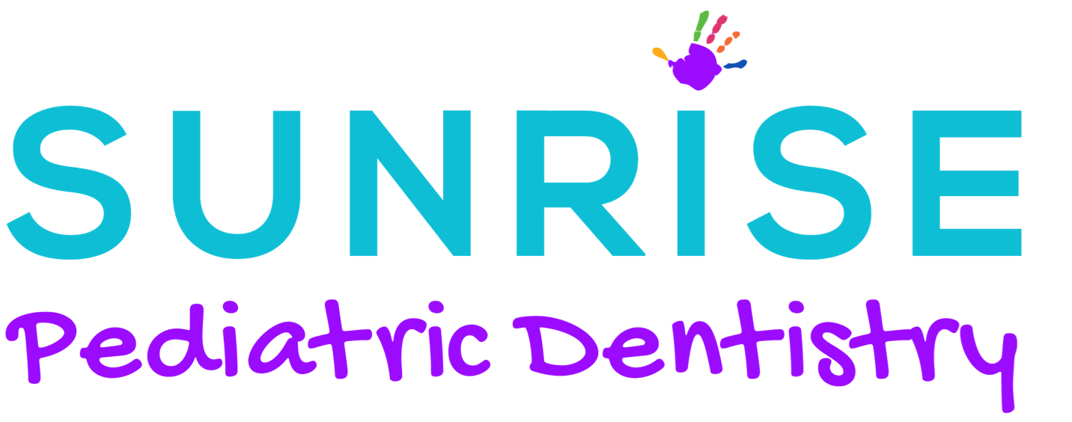
Post-op Instructions – Newborn/Infant

Your baby may be sore for several days following this procedure and some fussiness if expected in the beginning. Also, a white patch is expected to develop at the site of the procedure, which is normal. Post-frenectomy, there is no contraindication to feeding or use of a pacifier. OTC Tylenol can be used following all labels and directions, but normal calming techniques are encouraged first, and breast milk can be the best medicine.

Some bleeding is to be expected. Please hold pressure with gauze or use a moist tea bag to control bleeding.
Post-procedure complications are rare, however, pain and bleeding are the most common. If there is significant bleeding that you are unable to control, please call our office/page the on call doctor or proceed to the nearest emergency room.

If you baby is struggling to feed for more than 48 hours, please call the office. Frozen breast milk, syringe feeding and finger feeding can be helping in the first few days.

Post-Op Exercises

*Lingual- Each exercise in repetitions of 3, 5x a day for 6 weeks

- Lift tongue with two fingers fully until the diamond is fully visible, then release.

- Lightly massage around diamond border or sweep finger through underneath.

- Have baby suck on index finger (pointed towards roof of mouth) and pull back, allowing child to suck finger back in.

- After 1 week massage under the tongue, over the incision daily for 6 weeks as the body lays down collagen for that long.

*Labial- Each exercise in repetitions of 3, 5x a day for 6 weeks

- Lift lip with two fingers fully until the diamond is fully visible then release.

- Sweep finger under lip to check for re-attachment you will feel a bump, string, or finger will get caught.
Follow Up with Appropriate Team Member

- International Board-Certified Lactation Consultant

- Speech/ Language Pathologist

- Orofacial Myofunctional Therapy

Follow Up In office

- 1 Week

- 3 Weeks

- More often if needed: __________________________________________________

Notes: ________________________________________________________________________________________________________________________________________________________________________________________________________________________________________________________________________________________________________________________________________________________________________

Sunrise Pediatric Dentistry
3650 E. 1st Avenue Ste. 301
Denver, CO 80206
720-660-2467

